# Find the following:

1.If https://my.westcottcourses.com/images/common/triangle.gifABC https://my.westcottcourses.com/images/common/congruence.gif https://my.westcottcourses.com/images/common/triangle.gifDEF, name the corresponding sides.

2. If https://my.westcottcourses.com/images/common/triangle.gifSTU https://my.westcottcourses.com/images/common/congruence.gif https://my.westcottcourses.com/images/common/triangle.gifVWX, name the corresponding sides.

3.If    https://my.westcottcourses.com/images/common/congruence.gif ,    https://my.westcottcourses.com/images/common/congruence.gif    and    https://my.westcottcourses.com/images/common/congruence.gif ,   find the congruent triangles.

4.If    https://my.westcottcourses.com/images/common/congruence.gif ,    https://my.westcottcourses.com/images/common/congruence.gif    and    https://my.westcottcourses.com/images/common/congruence.gif ,   find the congruent triangles.

5.Which angles are congruent if   https://my.westcottcourses.com/images/common/triangle.gifABC https://my.westcottcourses.com/images/common/congruence.gif https://my.westcottcourses.com/images/common/triangle.gifDEF?

6.Which angles are congruent if   https://my.westcottcourses.com/images/common/triangle.gifRST https://my.westcottcourses.com/images/common/congruence.gif https://my.westcottcourses.com/images/common/triangle.gifXYZ?

# Determine if the following triangles are congruent. If the triangles are congruent, identify the property that shows congruency.

7.  
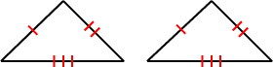

8.  
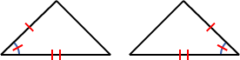

9.  
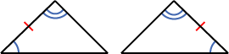

10.  
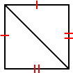

11.  
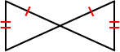

12.  
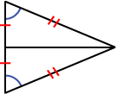

13.  
https://my.westcottcourses.com/images/homework/planegeometry/planegeometryhw2.3.13.gif

14.  
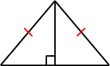

15.  
https://my.westcottcourses.com/images/homework/planegeometry/planegeometryhw2.3.15.gif

16.  
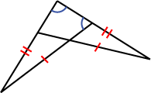

17.  
https://my.westcottcourses.com/images/homework/planegeometry/planegeometryhw2.3.17.gif

18.  
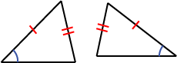

19.  
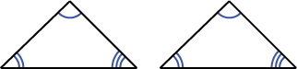

20.  
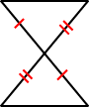

# Prove the following:

21.Prove Theorem 2.2.2:  
The ratio of the lengths of corresponding sides of two triangles are equal if and only if the triangles are similar.

22.Prove Theorem 2.2.3:  
If two ratios of the lengths of corresponding sides of two triangles are equal and the included angles are congruent, then the triangles are similar.

23.Prove Theorem 2.2.1:  
Two triangles are similar if and only if at least two sets of corresponding angles are congruent.

24.Given:    https://my.westcottcourses.com/images/common/congruence.gif   
  
      https://my.westcottcourses.com/images/common/congruence.gif   
  
     C is the midpoint of   
  
Prove:   https://my.westcottcourses.com/images/common/triangle.gifABC https://my.westcottcourses.com/images/common/congruence.gif https://my.westcottcourses.com/images/common/triangle.gifEDC  
  
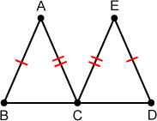

25.Given:   https://my.westcottcourses.com/images/common/angleNOarc.gifB https://my.westcottcourses.com/images/common/congruence.gif https://my.westcottcourses.com/images/common/angleNOarc.gifE  
  
     https://my.westcottcourses.com/images/common/angleNOarc.gif1 https://my.westcottcourses.com/images/common/congruence.gif https://my.westcottcourses.com/images/common/angleNOarc.gif2  
  
      https://my.westcottcourses.com/images/common/congruence.gif   
  
Prove:   https://my.westcottcourses.com/images/common/triangle.gifABD https://my.westcottcourses.com/images/common/congruence.gif https://my.westcottcourses.com/images/common/triangle.gifFEC  
  
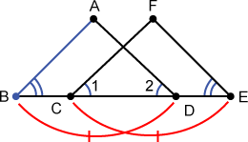

26.Given:   https://my.westcottcourses.com/images/common/angleNOarc.gifB https://my.westcottcourses.com/images/common/congruence.gif https://my.westcottcourses.com/images/common/angleNOarc.gifE  
  
     https://my.westcottcourses.com/images/common/angleNOarc.gif2 https://my.westcottcourses.com/images/common/congruence.gif https://my.westcottcourses.com/images/common/angleNOarc.gif3  
  
      https://my.westcottcourses.com/images/common/congruence.gif   
  
Prove:   https://my.westcottcourses.com/images/common/triangle.gifABD https://my.westcottcourses.com/images/common/congruence.gif https://my.westcottcourses.com/images/common/triangle.gifAEC  
  
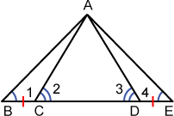

27.Given:   C is the midpoint of   
     https://my.westcottcourses.com/images/common/angleNOarc.gifB https://my.westcottcourses.com/images/common/congruence.gif https://my.westcottcourses.com/images/common/angleNOarc.gifE  
  
Prove:   https://my.westcottcourses.com/images/common/triangle.gifBCA https://my.westcottcourses.com/images/common/congruence.gif https://my.westcottcourses.com/images/common/triangle.gifECD  
  
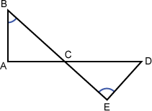

28.Given:    https://my.westcottcourses.com/images/common/congruence.gif   
  
      https://my.westcottcourses.com/images/common/congruence.gif   
  
Prove:    ||   
  
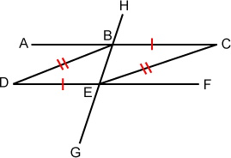

29.Given:   https://my.westcottcourses.com/images/common/angleNOarc.gifQ and https://my.westcottcourses.com/images/common/angleNOarc.gifS are right angles  
  
      https://my.westcottcourses.com/images/common/congruence.gif   
  
Prove:    ||   
  
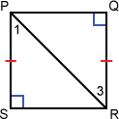

30.Explain why the following is true:  
If two triangles are congruent, then they are similar.

31.Explain why the following is true:  
If two triangles are similar, then they may not be congruent.